Top of Form

1. The editor of a major academic book publisher claims that a large part of the cost of books is the cost of paper. This implies that larger books will cost more money. As an experiment to analyze the claim, a university student visits the bookstore and records the number of pages and the selling price of 85 randomly selected books, and finds a sample correlation of 0.32. At a significance of 5%, conduct a test for the population correlation.

H0: p = 0

H1: p ≠ 0

This is a two tailed test for the population correlation. The p value of 0.002831 is less than the alpha value of 0.05 and the t calculated value of 3.077 is greater than the positive t critical value of 1.989. For both of these reasons we reject the null hypothesis and conclude that at a 5% level of significance there is a significant correlation between the population in regards to larger books costing more money.

1. Use the NFLData file for the following. In this question, we would like to explore 3 weather-related variables (temperature, wind speed, and humidity) for their correlation with total scores in a game and rushing yards.
   1. We would like to explore the correlation between the total score in a game and temperature, wind speed, and humidity. Conduct the three correlation tests and state your findings.

|  |  |
| --- | --- |
| 1. **3 With Variables:** | Temperature Humidity WindSpeed |
| **1 Variables:** | TotalScore |

| **Pearson Correlation Coefficients, N = 63 Prob > |r| under H0: Rho=0** | |
| --- | --- |
|  | **TotalScore** |
| **Temperature**  **Temperature** | -0.01062  0.9342 |
| **Humidity**  **Humidity** | -0.11354  0.3756 |
| **WindSpeed**  **WindSpeed** | 0.08460  0.5098 |

The variable with the greatest correlation coefficient with total scores in a game is humidity with a correlation of -0.11354. The variable with the smallest correlation coefficient with total scores in a game is temperature with a correlation of -0.01062. Windspeed has a correlation coefficient of 0.08460 with total score. These are not strong correlations. When analyzing the p values for each variable (temperature = 0.9342, humidity = 0.3756, and windspeed = 0.5098) to an assumed alpha of 0.05 we fail to reject the null and conclude that there is not sufficient evidence of a correlation between total score and any of the test variables (temperature, humidity, windspeed).

* 1. Similarly, explore if total rushing yards is correlated with temperature, wind speed, and humidity.

|  |  |
| --- | --- |
| **3 With Variables:** | Temperature Humidity WindSpeed |
| **1 Variables:** | TotalAVgRushingYard |

| **Pearson Correlation Coefficients, N = 63 Prob > |r| under H0: Rho=0** | |
| --- | --- |
|  | **TotalAVgRushingYard** |
| **Temperature**  **Temperature** | 0.15005  0.2405 |
| **Humidity**  **Humidity** | 0.13748  0.2826 |
| **WindSpeed**  **WindSpeed** | 0.09187  0.4739 |

The variable with the greatest correlation coefficient with total rushing yards is temperature with a correlation of 0.15005. The variable with the smallest correlation coefficient is windspeed with a correlation of 0.09187. Humidity has a correlation coefficient of 0.13748. These again are all not strong correlations. When analyzing the p values for each variable (temperature = 0.2405, humidity = 0.2826, and windspeed = 0.4739) to an assumed alpha of 0.05 we fail to reject the null and conclude that there is not sufficient evidence of a correlation between total rushing yards and any of the test variables (temperature, humidity, windspeed).

1. Using the Heart dataset in SASHELP directory, conduct a simple linear regression to examine if Smoking Status (independent variable) impacts Cholesterol (dependent variable).

|  |  |
| --- | --- |
| **Data Set** | SASHELP.HEART |
| **Dependent Variable** | Cholesterol |
| **Selection Method** | None |

|  |  |
| --- | --- |
| **Number of Observations Read** | 5209 |
| **Number of Observations Used** | 5049 |

| **Class Level Information** | | |
| --- | --- | --- |
| **Class** | **Levels** | **Values** |
| **Smoking_Status** | 5 | Heavy (16-25) Light (1-5) Moderate (6-15) Non-smoker Very Heavy (> 25) |

| **Dimensions** | |
| --- | --- |
| **Number of Effects** | 2 |
| **Number of Parameters** | 6 |

| **Least Squares Summary** | | | | |
| --- | --- | --- | --- | --- |
| **Step** | **Effect Entered** | **Number Effects In** | **Number Parms In** | **SBC** |
| **\* Optimal Value of Criterion** | | | | |
| **0** | **Intercept** | 1 | 1 | 38431.8642* |
| **1** | **Smoking_Status** | 2 | 5 | 38454.8895 |

**Least Squares Model (No Selection)**

| **Analysis of Variance** | | | | | |
| --- | --- | --- | --- | --- | --- |
| **Source** | **DF** | **Sum of Squares** | **Mean Square** | **F Value** | **Pr > F** |
| **Model** | 4 | 22345 | 5586.27930 | 2.77 | 0.0257 |
| **Error** | 5044 | 10168844 | 2016.02771 |  |  |
| **Corrected Total** | 5048 | 10191189 |  |  |  |

|  |  |
| --- | --- |
| **Root MSE** | 44.90020 |
| **Dependent Mean** | 227.44484 |
| **R-Square** | 0.0022 |
| **Adj R-Sq** | 0.0014 |
| **AIC** | 43473 |
| **AICC** | 43473 |
| **SBC** | 38455 |

| **Parameter Estimates** | | | | | |
| --- | --- | --- | --- | --- | --- |
| **Parameter** | **DF** | **Estimate** | **Standard Error** | **t Value** | **Pr > |t|** |
| **Intercept** | 1 | 227.855895 | 2.098048 | 108.60 | <.0001 |
| **Smoking_Status Heavy (16-25)** | 1 | -1.100793 | 2.522106 | -0.44 | 0.6625 |
| **Smoking_Status Light (1-5)** | 1 | -4.067263 | 2.825363 | -1.44 | 0.1501 |
| **Smoking_Status Moderate (6-15)** | 1 | -3.717352 | 2.825363 | -1.32 | 0.1883 |
| **Smoking_Status Non-smoker** | 1 | 1.412167 | 2.286789 | 0.62 | 0.5369 |
| **Smoking_Status Very Heavy (> 25)** | 0 | 0 | . | . | . |

**Model: MODEL1**

**Dependent Variable: Cholesterol**

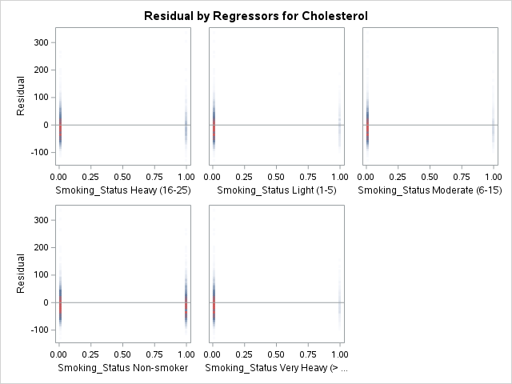

The model p value has a value of 0.0257 which is less than alpha of 0.05 therefore we conclude the model is significant. R-Square is 0.0022 which means that smoking status explains 0.22% of the variance in cholesterol. When looking at the parameter estimates we have an intercept of 227.855895 which aligns with 0 differential for very heavy smoking status making very heavy smoking status the reference group. Heavy smoking status impacts cholesterol 1.1008 less that very heavy smokers. Light smoking status impacts cholesterol 4.0673 less than very heavy smokers. Moderate smoking status impacts cholesterol 3.7174 less than very heavy smokers. Nonsmoking status impacts cholesterol 1.41217 more than very heavy smokers. The p values for each category (Heavy 0.6625, Light 0.1501, Moderate 0.1883, and Non-smoker 0.5369) are all greater than an alpha value of 0.05 and therefore we can conclude that each category is not significantly different from the very heavy smoking status group.

Regression line: Cholesterol = 227.855895 - 1.100793(Smoking_Status Heavy) - 4.067263(Smoking_Status Light) - 3.717352 (Smoking_Status Moderate) + 1.412167 (Smoking_Status Non-smoker)

The indicator variables for very heavy smoking status is zero. In this case cholesterol is 227.855895 for very heavy smoking status.

1. For this question, use the Franchises data file. The file has data on several variables explained below. We would like to understand if the amount of competition in the same county (officesincounty) predicts financial growth in 2011. Run the required analysis and articulate the findings.

|  |  |  |  |  |  |  |  |
| --- | --- | --- | --- | --- | --- | --- | --- |
| **Explanation** | Franchise ID number | How many years has the franchise been a part of the network | Financial growth in revenue from 2010 to 2011 | Financial growth in revenue from 2009 to 2010 | The distance from the franchise location to the headquarters | The number of other offices located in the same county (competition) | The total experience of the franchise’s leadership |

1. **Model: MODEL1**
2. **Dependent Variable: grth2011 grth2011**

|  |  |
| --- | --- |
| **Number of Observations Read** | 764 |
| **Number of Observations Used** | 764 |

| **Analysis of Variance** | | | | | |
| --- | --- | --- | --- | --- | --- |
| **Source** | **DF** | **Sum of Squares** | **Mean Square** | **F Value** | **Pr > F** |
| **Model** | 1 | 0.02854 | 0.02854 | 0.33 | 0.5662 |
| **Error** | 762 | 66.05049 | 0.08668 |  |  |
| **Corrected Total** | 763 | 66.07904 |  |  |  |

|  |  |  |  |
| --- | --- | --- | --- |
| **Root MSE** | 0.29442 | **R-Square** | 0.0004 |
| **Dependent Mean** | 0.04174 | **Adj R-Sq** | -0.0009 |
| **Coeff Var** | 705.28445 |  |  |

| **Parameter Estimates** | | | | | | |
| --- | --- | --- | --- | --- | --- | --- |
| **Variable** | **Label** | **DF** | **Parameter Estimate** | **Standard Error** | **t Value** | **Pr > |t|** |
| **Intercept** | Intercept | 1 | 0.04628 | 0.01327 | 3.49 | 0.0005 |
| **officesincounty** | officesincounty | 1 | -0.00050256 | 0.00087576 | -0.57 | 0.5662 |

The model p value is 0.5662 which is greater than the alpha value of 0.05 and therefore we fail to reject he null and conclude the model is not useful. R-Square is 0.0004 which means 0.04% of the variance in financial growth in revenue from 2010 – 2011 is explained by the number of other offices located in the same county. The intercept slope is -0.00050256 for the number of other offices located in the same county which means the financial growth in revenue from 2010 to 2011 is expected to decrease by 0.00050256. The p value for the parameter estimates is also 0.5662 which means the amount of competition in the same county (officesincounty) does not predict financial growth in 2011. We can conclude there is no influence of the number of other offices located in the same county (competition) on the financial growth in revenue from 2010 to 2011.

Regression line: Financial growth in revenue from 2010 to 2011 = 0.04628 -0.00050256(officesincounty)

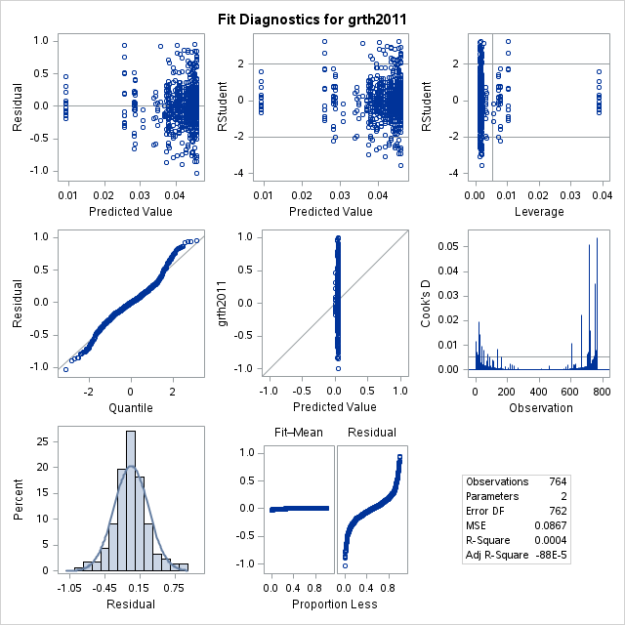

Assumptions: According to the Residual/Percent histogram and the Quantile/Residual plot the errors are normally distributed. When looking at the predicted values/residuals plot there doesn’t seem to be a megaphone effect so heterogeneity isn’t an issue. The data isn’t time series so autocorrelation is not an issue.

**Model: MODEL1**

**Dependent Variable: grth2011 grth2011**

| **Output Statistics** | | | | | | | | | | | | | | |
| --- | --- | --- | --- | --- | --- | --- | --- | --- | --- | --- | --- | --- | --- | --- |
| **Obs** | **Dependent Variable** | **Predicted Value** | **Std Error Mean Predict** | **Residual** | **Std Error Residual** | **Student Residual** | -2-1 0 1 2 | **Cook's D** | **RStudent** | **Hat Diag H** | **Cov Ratio** | **DFFITS** | **DFBETAS** | |
| **Intercept** | **officesincounty** |
| **1** | -0.992841 | 0.0458 | 0.0128 | -1.0386 | 0.294 | -3.531 | |******|      | | 0.012 | -3.5580 | 0.0019 | 0.9719 | -0.1544 | -0.1542 | 0.0851 |
| **2** | -0.852945 | 0.0418 | 0.0107 | -0.8947 | 0.294 | -3.041 | |******|      | | 0.006 | -3.0575 | 0.0013 | 0.9797 | -0.1107 | -0.0890 | 0.0003 |
| **3** | -0.835332 | 0.0372 | 0.0132 | -0.8726 | 0.294 | -2.967 | | *****|      | | 0.009 | -2.9821 | 0.0020 | 0.9816 | -0.1342 | -0.0392 | -0.0796 |
| **4** | -0.814771 | 0.0458 | 0.0128 | -0.8606 | 0.294 | -2.926 | | *****|      | | 0.008 | -2.9403 | 0.0019 | 0.9821 | -0.1276 | -0.1274 | 0.0703 |
| **5** | -0.812227 | 0.0453 | 0.0123 | -0.8575 | 0.294 | -2.915 | | *****|      | | 0.007 | -2.9296 | 0.0017 | 0.9821 | -0.1225 | -0.1217 | 0.0613 |
| **6** | -0.756835 | 0.0392 | 0.0115 | -0.7961 | 0.294 | -2.706 | | *****|      | | 0.006 | -2.7173 | 0.0015 | 0.9850 | -0.1063 | -0.0550 | -0.0402 |
| **7** | -0.746037 | 0.0458 | 0.0128 | -0.7918 | 0.294 | -2.692 | | *****|      | | 0.007 | -2.7031 | 0.0019 | 0.9855 | -0.1173 | -0.1171 | 0.0647 |
| **8** | -0.731307 | 0.0453 | 0.0123 | -0.7766 | 0.294 | -2.640 | | *****|      | | 0.006 | -2.6504 | 0.0017 | 0.9861 | -0.1109 | -0.1101 | 0.0555 |
| **9** | -0.726632 | 0.0403 | 0.0110 | -0.7669 | 0.294 | -2.607 | | *****|      | | 0.005 | -2.6166 | 0.0014 | 0.9862 | -0.0975 | -0.0623 | -0.0231 |
| **10** | -0.715381 | 0.0443 | 0.0115 | -0.7597 | 0.294 | -2.582 | | *****|      | | 0.005 | -2.5919 | 0.0015 | 0.9867 | -0.1016 | -0.0985 | 0.0388 |
| **11** | -0.711223 | 0.0458 | 0.0128 | -0.7570 | 0.294 | -2.574 | | *****|      | | 0.006 | -2.5832 | 0.0019 | 0.9871 | -0.1121 | -0.1119 | 0.0618 |
| **12** | -0.707272 | 0.0418 | 0.0107 | -0.7490 | 0.294 | -2.546 | | *****|      | | 0.004 | -2.5550 | 0.0013 | 0.9869 | -0.0925 | -0.0744 | 0.0003 |
| **13** | -0.678858 | 0.0443 | 0.0115 | -0.7231 | 0.294 | -2.458 | |  ****|      | | 0.005 | -2.4662 | 0.0015 | 0.9883 | -0.0966 | -0.0937 | 0.0370 |
| **14** | -0.678322 | 0.0428 | 0.0108 | -0.7211 | 0.294 | -2.451 | |  ****|      | | 0.004 | -2.4590 | 0.0013 | 0.9882 | -0.0903 | -0.0803 | 0.0149 |
| **15** | -0.676970 | 0.0448 | 0.0119 | -0.7217 | 0.294 | -2.453 | |  ****|      | | 0.005 | -2.4616 | 0.0016 | 0.9885 | -0.0995 | -0.0979 | 0.0442 |
| **16** | -0.671742 | 0.0372 | 0.0132 | -0.7090 | 0.294 | -2.411 | |  ****|      | | 0.006 | -2.4182 | 0.0020 | 0.9894 | -0.1088 | -0.0318 | -0.0646 |
| **17** | -0.655267 | 0.0448 | 0.0119 | -0.7000 | 0.294 | -2.380 | |  ****|      | | 0.005 | -2.3870 | 0.0016 | 0.9894 | -0.0965 | -0.0950 | 0.0429 |
| **18** | -0.636619 | 0.0428 | 0.0108 | -0.6794 | 0.294 | -2.309 | |  ****|      | | 0.004 | -2.3157 | 0.0013 | 0.9900 | -0.0850 | -0.0757 | 0.0140 |
| **19** | -0.628347 | 0.0282 | 0.0259 | -0.6565 | 0.293 | -2.239 | |  ****|      | | 0.020 | -2.2446 | 0.0077 | 0.9972 | -0.1983 | 0.0423 | -0.1807 |
| **20** | -0.601417 | 0.0382 | 0.0123 | -0.6397 | 0.294 | -2.175 | |  ****|      | | 0.004 | -2.1799 | 0.0017 | 0.9919 | -0.0910 | -0.0364 | -0.0452 |
| **21** | -0.597830 | 0.0453 | 0.0123 | -0.6431 | 0.294 | -2.186 | |  ****|      | | 0.004 | -2.1917 | 0.0017 | 0.9918 | -0.0917 | -0.0911 | 0.0459 |
| **22** | -0.584877 | 0.0433 | 0.0110 | -0.6281 | 0.294 | -2.135 | |  ****|      | | 0.003 | -2.1400 | 0.0014 | 0.9920 | -0.0799 | -0.0737 | 0.0193 |
| **23** | -0.573349 | 0.0377 | 0.0127 | -0.6111 | 0.294 | -2.078 | |  ****|      | | 0.004 | -2.0821 | 0.0019 | 0.9932 | -0.0901 | -0.0311 | -0.0494 |
| **24** | -0.567266 | 0.0337 | 0.0176 | -0.6010 | 0.294 | -2.045 | |  ****|      | | 0.007 | -2.0492 | 0.0036 | 0.9952 | -0.1226 | -0.0015 | -0.0975 |
| **25** | -0.558231 | 0.0433 | 0.0110 | -0.6015 | 0.294 | -2.044 | |  ****|      | | 0.003 | -2.0487 | 0.0014 | 0.9930 | -0.0764 | -0.0706 | 0.0185 |
| **732** | 0.636660 | 0.0392 | 0.0115 | 0.5974 | 0.294 | 2.031 | |      |****  | | 0.003 | 2.0349 | 0.0015 | 0.9933 | 0.0796 | 0.0412 | 0.0301 |
| **733** | 0.637137 | 0.0453 | 0.0123 | 0.5919 | 0.294 | 2.012 | |      |****  | | 0.004 | 2.0161 | 0.0017 | 0.9937 | 0.0843 | 0.0838 | -0.0422 |
| **734** | 0.647119 | 0.0443 | 0.0115 | 0.6028 | 0.294 | 2.049 | |      |****  | | 0.003 | 2.0535 | 0.0015 | 0.9931 | 0.0805 | 0.0780 | -0.0308 |
| **735** | 0.654282 | 0.0458 | 0.0128 | 0.6085 | 0.294 | 2.069 | |      |****  | | 0.004 | 2.0732 | 0.0019 | 0.9933 | 0.0900 | 0.0898 | -0.0496 |
| **736** | 0.656445 | 0.0458 | 0.0128 | 0.6107 | 0.294 | 2.076 | |      |****  | | 0.004 | 2.0806 | 0.0019 | 0.9932 | 0.0903 | 0.0902 | -0.0498 |
| **737** | 0.666387 | 0.0433 | 0.0110 | 0.6231 | 0.294 | 2.118 | |      |****  | | 0.003 | 2.1228 | 0.0014 | 0.9922 | 0.0792 | 0.0731 | -0.0192 |
| **738** | 0.672467 | 0.0458 | 0.0128 | 0.6267 | 0.294 | 2.131 | |      |****  | | 0.004 | 2.1356 | 0.0019 | 0.9926 | 0.0927 | 0.0925 | -0.0511 |
| **739** | 0.681740 | 0.0448 | 0.0119 | 0.6370 | 0.294 | 2.165 | |      |****  | | 0.004 | 2.1705 | 0.0016 | 0.9919 | 0.0877 | 0.0863 | -0.0390 |
| **740** | 0.691529 | 0.0438 | 0.0112 | 0.6478 | 0.294 | 2.202 | |      |****  | | 0.004 | 2.2073 | 0.0015 | 0.9914 | 0.0842 | 0.0800 | -0.0265 |
| **741** | 0.695557 | 0.0448 | 0.0119 | 0.6508 | 0.294 | 2.212 | |      |****  | | 0.004 | 2.2179 | 0.0016 | 0.9914 | 0.0896 | 0.0882 | -0.0398 |
| **742** | 0.711149 | 0.0382 | 0.0123 | 0.6729 | 0.294 | 2.288 | |      |****  | | 0.005 | 2.2939 | 0.0017 | 0.9906 | 0.0957 | 0.0383 | 0.0476 |
| **743** | 0.713978 | 0.0438 | 0.0112 | 0.6702 | 0.294 | 2.278 | |      |****  | | 0.004 | 2.2843 | 0.0015 | 0.9905 | 0.0871 | 0.0828 | -0.0274 |
| **744** | 0.719313 | 0.0453 | 0.0123 | 0.6740 | 0.294 | 2.291 | |      |****  | | 0.005 | 2.2978 | 0.0017 | 0.9906 | 0.0961 | 0.0955 | -0.0481 |
| **745** | 0.733814 | 0.0433 | 0.0110 | 0.6905 | 0.294 | 2.347 | |      |****  | | 0.004 | 2.3541 | 0.0014 | 0.9896 | 0.0878 | 0.0811 | -0.0213 |
| **746** | 0.738125 | 0.0458 | 0.0128 | 0.6923 | 0.294 | 2.354 | |      |****  | | 0.005 | 2.3609 | 0.0019 | 0.9900 | 0.1025 | 0.1023 | -0.0565 |
| **747** | 0.752990 | 0.0377 | 0.0127 | 0.7152 | 0.294 | 2.432 | |      |****  | | 0.006 | 2.4396 | 0.0019 | 0.9890 | 0.1056 | 0.0364 | 0.0579 |
| **748** | 0.780384 | 0.0458 | 0.0128 | 0.7346 | 0.294 | 2.497 | |      |****  | | 0.006 | 2.5061 | 0.0019 | 0.9881 | 0.1088 | 0.1086 | -0.0599 |
| **749** | 0.785020 | 0.0418 | 0.0107 | 0.7433 | 0.294 | 2.526 | |      |***** | | 0.004 | 2.5352 | 0.0013 | 0.9872 | 0.0918 | 0.0738 | -0.0003 |
| **750** | 0.785910 | 0.0257 | 0.0300 | 0.7602 | 0.293 | 2.596 | |      |***** | | 0.035 | 2.6055 | 0.0104 | 0.9953 | 0.2665 | -0.0724 | 0.2490 |
| **751** | 0.798605 | 0.0458 | 0.0128 | 0.7528 | 0.294 | 2.559 | |      |***** | | 0.006 | 2.5688 | 0.0019 | 0.9873 | 0.1115 | 0.1113 | -0.0614 |
| **752** | 0.813746 | 0.0458 | 0.0128 | 0.7680 | 0.294 | 2.611 | |      |***** | | 0.006 | 2.6209 | 0.0019 | 0.9866 | 0.1137 | 0.1136 | -0.0627 |
| **753** | 0.848856 | 0.0413 | 0.0107 | 0.8076 | 0.294 | 2.745 | |      |***** | | 0.005 | 2.7567 | 0.0013 | 0.9842 | 0.1001 | 0.0754 | 0.0079 |
| **754** | 0.858791 | 0.0403 | 0.0110 | 0.8185 | 0.294 | 2.782 | |      |***** | | 0.005 | 2.7945 | 0.0014 | 0.9837 | 0.1041 | 0.0665 | 0.0247 |
| **755** | 0.872583 | 0.0443 | 0.0115 | 0.8283 | 0.294 | 2.816 | |      |***** | | 0.006 | 2.8285 | 0.0015 | 0.9834 | 0.1108 | 0.1075 | -0.0424 |
| **756** | 0.880511 | 0.0433 | 0.0110 | 0.8372 | 0.294 | 2.846 | |      |***** | | 0.006 | 2.8591 | 0.0014 | 0.9828 | 0.1067 | 0.0985 | -0.0258 |
| **757** | 0.887353 | 0.0453 | 0.0123 | 0.8421 | 0.294 | 2.863 | |      |***** | | 0.007 | 2.8763 | 0.0017 | 0.9829 | 0.1203 | 0.1195 | -0.0602 |
| **758** | 0.895561 | 0.0458 | 0.0128 | 0.8498 | 0.294 | 2.889 | |      |***** | | 0.008 | 2.9031 | 0.0019 | 0.9826 | 0.1260 | 0.1258 | -0.0694 |
| **759** | 0.903861 | 0.0433 | 0.0110 | 0.8606 | 0.294 | 2.925 | |      |***** | | 0.006 | 2.9397 | 0.0014 | 0.9816 | 0.1097 | 0.1013 | -0.0265 |
| **760** | 0.906665 | 0.0423 | 0.0107 | 0.8644 | 0.294 | 2.938 | |      |***** | | 0.006 | 2.9528 | 0.0013 | 0.9813 | 0.1073 | 0.0912 | -0.0091 |
| **761** | 0.958431 | 0.0357 | 0.0149 | 0.9227 | 0.294 | 3.138 | |      |******| | 0.013 | 3.1565 | 0.0026 | 0.9794 | 0.1604 | 0.0247 | 0.1125 |
| **762** | 0.964955 | 0.0257 | 0.0300 | 0.9393 | 0.293 | 3.207 | |      |******| | 0.054 | 3.2267 | 0.0104 | 0.9860 | 0.3300 | -0.0897 | 0.3084 |
| **763** | 0.977576 | 0.0403 | 0.0110 | 0.9373 | 0.294 | 3.186 | |      |******| | 0.007 | 3.2052 | 0.0014 | 0.9775 | 0.1194 | 0.0763 | 0.0283 |
| **764** | 0.994107 | 0.0453 | 0.0123 | 0.9488 | 0.294 | 3.226 | |      |******| | 0.009 | 3.2457 | 0.0017 | 0.9771 | 0.1358 | 0.1349 | -0.0680 |

|  |  |
| --- | --- |
| **Sum of Residuals** | 0 |
| **Sum of Squared Residuals** | 66.05049 |
| **Predicted Residual SS (PRESS)** | 66.37450 |

Above are all rows where the absolute value of RStudent is greater than 2. These are the outliers.

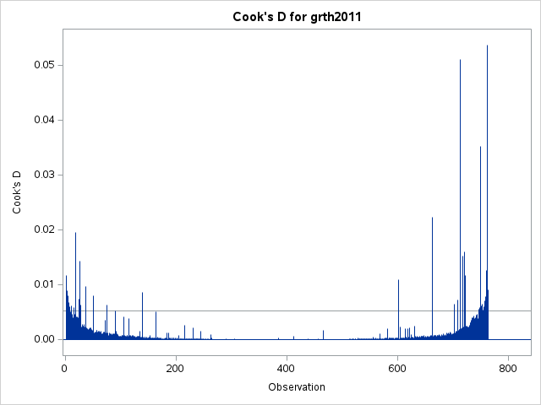

The above Cook’s D plot shows many influential observations that behave very differently from the others. These are shown as the blue lines on the x axis that extend past the horizontal line on the y axis that holds a value of roughly 0.005.

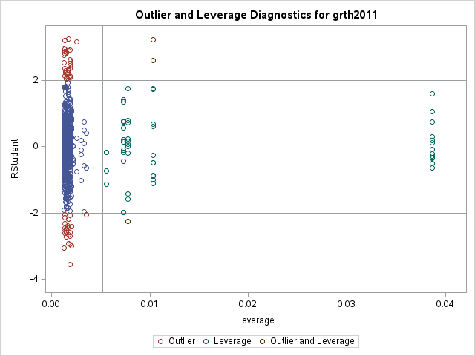

As shown in the Outlier and Leverage Diagnostics for grth2011 plot we have a number of outliers and leverage points. There are 3 points where the data is both and outlier and leverage point. These 3 data points are of great concern and may need to be deleted from the data and documented.